N-gonal Rotunda
# Source: AI Source: Provided by: [Data Path: Persons Table -> ID Column: 1, Name_En Column: Motasem Essam] -> From: [ChatGPT] on [7/25/2026]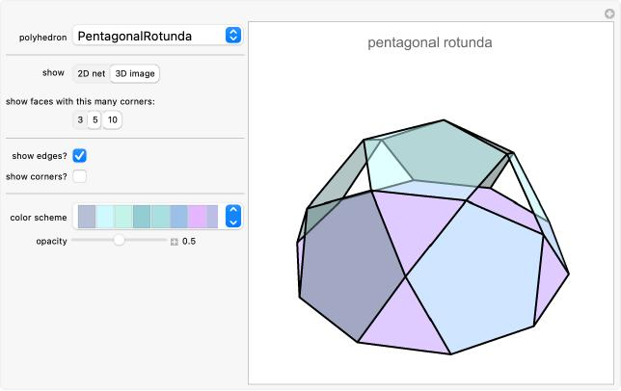

Definition
# Source: AI Source: Provided by: [Data Path: Persons Table -> ID Column: 1, Name_En Column: Motasem Essam] -> From: [ChatGPT] on [7/25/2026]
An N-gonal Rotunda is a generalized rotunda-type polyhedron constructed with an N-gonal upper base and a parallel 2N-gonal lower base.
Its lateral surface consists of alternating triangular and pentagonal faces arranged cyclically around the solid.
For a generalized N-gonal Rotunda, where $n$ represents the number of sides of the upper base:
- 1 N-gonal upper base.
- 1 (2N)-gonal lower base.
- 2N triangular lateral faces.
- N pentagonal lateral faces.
The N-gonal Rotunda represents the general form of the rotunda family rather than one particular polygonal case.
It is a generalized construction and is not necessarily a classical Johnson solid.

Geometric Structure
# Source: AI Source: Provided by: [Data Path: Persons Table -> ID Column: 1, Name_En Column: Motasem Essam] -> From: [ChatGPT] on [7/25/2026]
The structure is based on two parallel polygonal bases:
- Upper Base: A regular N-gon with N sides.
- Lower Base: A regular 2N-gon with 2N sides, positioned parallel to the upper base and rotated relative to it.
- Lateral Surface: A band of 3N faces consisting of 2N triangles and N pentagons.
The triangular and pentagonal faces alternate around the lateral structure.

Face Composition
# Source: AI Source: Provided by: [Data Path: Persons Table -> ID Column: 1, Name_En Column: Motasem Essam] -> From: [ChatGPT] on [7/25/2026]
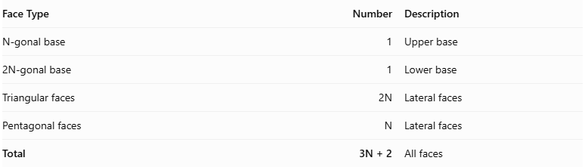
Face Type | Number | Description
N-gonal base | 1 | Upper base
2N-gonal base | 1 | Lower base
Triangular faces | $$2N$$ | Lateral faces
Pentagonal faces | $$N$$ | Lateral faces
Total | 3N + 2 | All faces

Mathematical Properties
# Source: AI Source: Provided by: [Data Path: Persons Table -> ID Column: 1, Name_En Column: Motasem Essam] -> From: [ChatGPT] on [7/25/2026]
For a generalized N-gonal Rotunda:
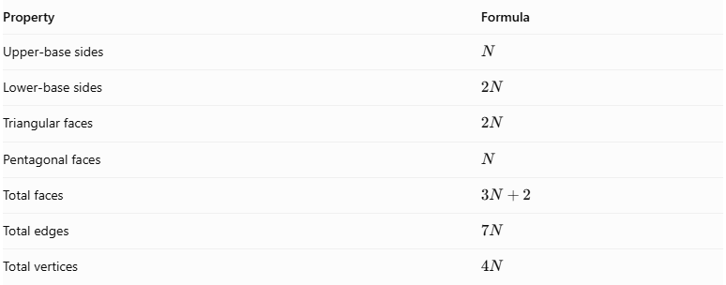
Property | Formula
Upper-base sides | $$N$$
Lower-base sides | $$2N$$
Triangular faces | $$2N$$
Pentagonal faces | $$N$$
Total faces | $$3N+2$$
Total edges | $$7N$$
Total vertices | $$4N$$
Euler's Polyhedron Formula:
$$V-E+F=2$$
Substituting the general formulas:
$$4N-7N+(3N+2)=2$$
$$\boxed{2=2}$$
Therefore, the general face, edge, and vertex counts satisfy Euler's formula for a topologically spherical polyhedron.

Geometric Characteristics
# Source: AI Source: Provided by: [Data Path: Persons Table -> ID Column: 1, Name_En Column: Motasem Essam] -> From: [ChatGPT] on [7/25/2026]
- Upper Base Shape: N-gon.
- Lower Base Shape: 2N-gon.
- Lateral Face Types: Triangles and pentagons.
- Total Faces: $3N+2$.
- Total Edges: $7N$.
- Total Vertices: $4N$.
- Rotational Symmetry: N-fold rotational symmetry in the symmetric arrangement.
- Cyclic Arrangement: The lateral faces are arranged around a central axis.
- Convexity and Regularity: These depend on the particular geometric realization. The generalized construction does not automatically require all faces to be regular or all edges to have equal lengths.

General Rotunda Formulas
# Source: AI Source: Provided by: [Data Path: Persons Table -> ID Column: 1, Name_En Column: Motasem Essam] -> From: [ChatGPT] on [7/25/2026]
For an N-gonal Rotunda:
$$\boxed{F=3N+2}$$
$$\boxed{E=7N}$$
$$\boxed{V=4N}$$
Where:
- $F$ = Total number of faces.
- $E$ = Total number of edges.
- $V$ = Total number of vertices.
- $N$ = Number of sides of the upper polygonal base.
The central angles of the two regular bases are:
Upper base:
$$α=\frac{{360}^{°}}{N}$$
Lower base:
$$β=\frac{{360}^{°}}{2N}=\frac{{180}^{°}}{N}$$

Examples of N-gonal Rotundas
# Source: AI Source: Provided by: [Data Path: Persons Table -> ID Column: 1, Name_En Column: Motasem Essam] -> From: [ChatGPT] on [7/25/2026]
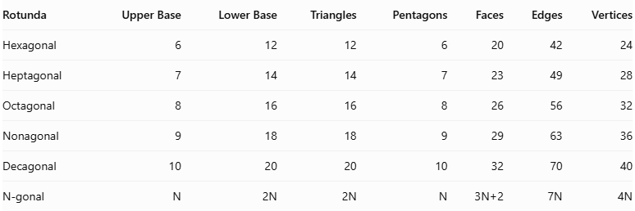
Rotunda | Upper Base | Lower Base | Triangles | Pentagons | Faces | Edges | Vertices
Hexagonal | 6 | 12 | 12 | 6 | 20 | 42 | 24
Heptagonal | 7 | 14 | 14 | 7 | 23 | 49 | 28
Octagonal | 8 | 16 | 16 | 8 | 26 | 56 | 32
Nonagonal | 9 | 18 | 18 | 9 | 29 | 63 | 36
Decagonal | 10 | 20 | 20 | 10 | 32 | 70 | 40
N-gonal | $$N$$ | $$2N$$ | $$2N$$ | $$N$$ | $$3N+2$$ | $$7N$$ | $$4N$$

Construction of N-gonal Rotunda

Geometric Instruments Used
# Source: AI Source: Provided by: [Data Path: Persons Table -> ID Column: 1, Name_En Column: Motasem Essam] -> From: [ChatGPT] on [7/25/2026]
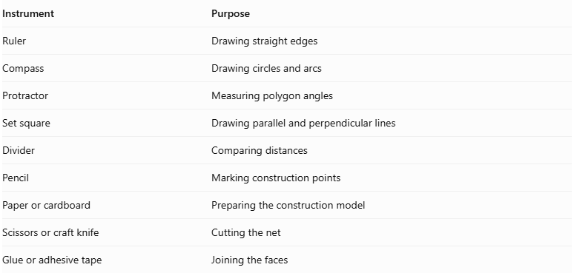
Instrument | Purpose
Ruler | Drawing straight edges
Compass | Drawing circles and arcs
Protractor | Measuring polygon angles
Set square | Drawing parallel and perpendicular lines
Divider | Comparing distances
Pencil | Marking construction points
Paper or cardboard | Preparing the construction model
Scissors or craft knife | Cutting the net
Glue or adhesive tape | Joining the faces

Instrument-Based Construction Procedures
# Source: AI Source: Provided by: [Data Path: Persons Table -> ID Column: 1, Name_En Column: Motasem Essam] -> From: [ChatGPT] on [7/25/2026]
No coordinate-based construction
The construction uses geometric instruments, polygon geometry, measured lengths, angles, and face-to-face edge matching.
The exact construction method depends on the value of N. Some regular polygons can be constructed exactly using a compass and straightedge, while others require measured construction or templates.

A. Construct the Upper Regular N-gonal Base
# Source: AI Source: Provided by: [Data Path: Persons Table -> ID Column: 1, Name_En Column: Motasem Essam] -> From: [ChatGPT] on [7/25/2026]
- Draw a circle using a compass.
- Mark its center.
- Divide the circumference into N equal central angles.
- Each central angle measures:
$$\frac{{360}^{°}}{N}$$
- Mark the N points on the circumference.
- Join consecutive points using a ruler.
- Verify that the N sides are approximately equal.
- Label the vertices.

B. Construct the Lower Regular 2N-gonal Base
# Source: AI Source: Provided by: [Data Path: Persons Table -> ID Column: 1, Name_En Column: Motasem Essam] -> From: [ChatGPT] on [7/25/2026]
- Draw a second circle using a compass.
- Mark its center.
- Divide the circumference into 2N equal central angles.
- Each central angle measures:
$$\frac{{360}^{°}}{2N}=\frac{{180}^{°}}{N}$$
- Mark the 2N points on the circumference.
- Join consecutive points using a ruler.
- Verify that the 2N sides are approximately equal.
- Label the vertices.

C. Construct the 2N Triangular Lateral Faces
# Source: AI Source: Provided by: [Data Path: Persons Table -> ID Column: 1, Name_En Column: Motasem Essam] -> From: [ChatGPT] on [7/25/2026]
- Prepare 2N triangular faces.
- Determine their side lengths and angles from the selected N-gonal Rotunda model.
- Arrange the triangles according to the intended lateral face pattern.
- Match their edges to the appropriate pentagonal faces and bases.
- Verify that each triangle fits its neighboring faces without gaps or unintended overlaps.

D. Construct the N Pentagonal Lateral Faces
# Source: AI Source: Provided by: [Data Path: Persons Table -> ID Column: 1, Name_En Column: Motasem Essam] -> From: [ChatGPT] on [7/25/2026]
- Prepare N pentagonal faces.
- Determine their side lengths and interior angles from the selected model.
- Arrange the pentagons alternately within the lateral face arrangement.
- Match their edges with the appropriate neighboring triangular faces.
- Verify that the pentagons complete the lateral structure correctly.

E. Arrange the Faces
# Source: AI Source: Provided by: [Data Path: Persons Table -> ID Column: 1, Name_En Column: Motasem Essam] -> From: [ChatGPT] on [7/25/2026]
- Position the regular N-gonal upper base and regular 2N-gonal lower base parallel to each other.
- Arrange the 2N triangles and N pentagons between the two bases.
- Check the lengths of all shared edges.
- Verify the intended N-fold rotational arrangement.
- Confirm that every edge belongs to exactly two faces and that the surface closes without gaps or overlaps.

F. Assemble the Solid
# Source: AI Source: Provided by: [Data Path: Persons Table -> ID Column: 1, Name_En Column: Motasem Essam] -> From: [ChatGPT] on [7/25/2026]
- Prepare a verified construction net or separate face pieces with the correct adjacency arrangement.
- Add joining tabs if using paper or cardboard.
- Cut out the faces.
- Fold the required edges if using a net.
- Join the matching lateral faces.
- Attach the upper N-gonal base and lower 2N-gonal base.
- Inspect the completed model from several directions.
Construction accuracy: The N pentagons and 2N triangles must have dimensions and angles compatible with the selected generalized model. Simply using regular pentagons, equilateral triangles, and regular polygonal bases does not guarantee a valid closed N-gonal Rotunda. The face geometry and adjacency must be verified before assembly.

Key Points
# Source: AI Source: Provided by: [Data Path: Persons Table -> ID Column: 1, Name_En Column: Motasem Essam] -> From: [ChatGPT] on [7/25/2026]
- The N-gonal Rotunda has an N-sided upper base and a 2N-sided lower base.
- Its lateral surface contains 2N triangles and N pentagons.
- It has $3N+2$ faces.
- It has $7N$ edges.
- It has $4N$ vertices.
- It has N-fold rotational symmetry in its symmetric arrangement.
- It belongs to the generalized Rotunda family.
- Its mathematical structure satisfies Euler's polyhedron formula.

Main Classification
# Source: AI Source: Provided by: [Data Path: Persons Table -> ID Column: 1, Name_En Column: Motasem Essam] -> From: [ChatGPT] on [7/25/2026]
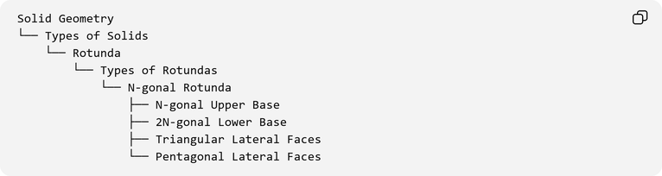
Solid Geometry
└── Types of Solids
└── Rotunda
└── Types of Rotundas
└── N-gonal Rotunda
├── N-gonal Upper Base
├── 2N-gonal Lower Base
├── Triangular Lateral Faces
└── Pentagonal Lateral Faces

Conclusion
# Source: AI Source: Provided by: [Data Path: Persons Table -> ID Column: 1, Name_En Column: Motasem Essam] -> From: [ChatGPT] on [7/25/2026]
The N-gonal Rotunda is a generalized rotunda-type polyhedron characterized by an N-gonal upper base, a parallel 2N-gonal lower base, and an alternating arrangement of triangular and pentagonal lateral faces.
Its general mathematical structure consists of:
$$\boxed{F=3N+2}$$
$$\boxed{E=7N}$$
$$\boxed{V=4N}$$
These formulas describe the combinatorial structure of the generalized N-gonal Rotunda and provide a unified mathematical framework for studying different members of the Rotunda family.

